ECE361 – Computer Networks

Wireshark Lab 1: HTTP

First Name: Shayshu Last Name: Nahata-Ragubance

First Name: _______________________ Last Name: ________________

Group Details:
Student #: 1005035196 Student #:
Mark:
 | Question | Answer
1 | Is your browser running HTTP version 1.0 or 1.1? What version of HTTP is the  server running? | Both my browser and the server are running HTTP version 1.1  See Figure 1
2 | What languages (if any) does your browser indicate that it can accept to the  server? | en-CA,en;q=0.9,fr-CA;q=0.8,fr;q=0.7,en-GB;q=0.6,en-US;q=0.5  So Canadian, US, and UK English and Canadian and normal French.  See Figure 2
3 | What is the IP address of your computer? Of the gaia.cs.umass.edu server? | My IP address is 10.0.0.230 and the server IP is 128.119.245.12  See Figure 3
4 | What is the status code returned from the server to your browser? | Status code 200, meaning OK  See figure 4
5 | When was the HTML file that you are retrieving last modified at the server? | Sun, Jan 31, 2021 6:59:01 GMT  See figure 5
6 | How many bytes of content are being returned to your browser? | 128 Bytes.  See figure 6
7 | By inspecting the raw data in the packet content window, do you see any headers within the data that are not displayed in the packet-listing window? If so, name one. | ???
8 | Inspect the contents of the first HTTP GET request from your browser to the  server. Do you see an “IF-MODIFIED-SINCE” line in the HTTP GET? | No. Which is somewhat expected because the cache was cleared before doing this part.  See figure 8
9 | Inspect the contents of the server response. Did the server explicitly return the contents of the file? How can you tell? | Yes we can clearly read the entire HTML contents in the Line based text data field. It returned 10 lines of text/html.  See figure 9
10 | Now inspect the contents of the second HTTP GET request from your browser to the server. Do you see an “IF-MODIFIED-SINCE:” line in the HTTP GET? If so, what information follows the “IF-MODIFIED-SINCE:” header? | Yes, it contains the date it was last modified which tells the server that if the file they have has not been modified since “Sun, 31 Jan 2021” then we can use the file we have in memory.  See figure 10
11 | What is the HTTP status code and phrase returned from the server in response to this second HTTP GET? Did the server explicitly return the contents of the file?  Explain. | The server returns status code 304 which means that the file has not been modified. Furthermore, the server does not send back any text/html data because we can use the data stored locally in memory instead.
12 | How many HTTP GET request messages were sent by your browser?
13 | How many data-containing TCP segments were needed to carry the single HTTP response?
14 | What is the status code and phrase associated with the response to the HTTP GET request?
15 | Are there any HTTP status lines in the transmitted data associated with a TCPinduced “Continuation”?
16 | How many HTTP GET request messages were sent by your browser? To which Internet addresses were these GET requests sent?
17 | Can you tell whether your browser downloaded the two images serially, or  whether they were downloaded from the two web sites in parallel? Explain.
18 (optional) | What is the server’s response (status code and phrase) in response to the initial HTTP GET message from your browser?
19  (optional) | When your browser’s sends the HTTP GET message for the second time, what  new field is included in the HTTP GET message?

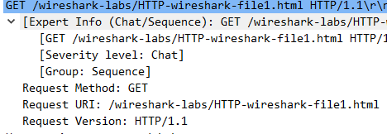

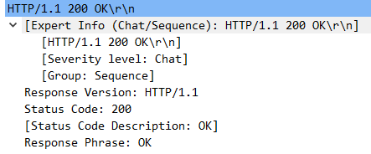
Figure 1: Question 1 HTTP version
Figure 2: Question 2 Accepted language

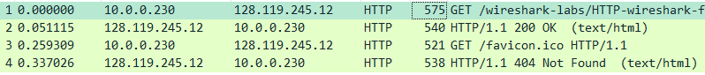
Figure 3: Question 3 IP addresses

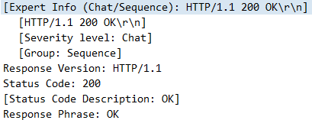
Figure 4: Question 4 Sever response code

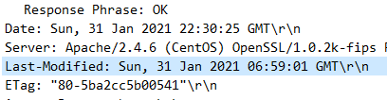
Figure 5: Question 5 Last modified

Figure 6: Question 6 size of file returned

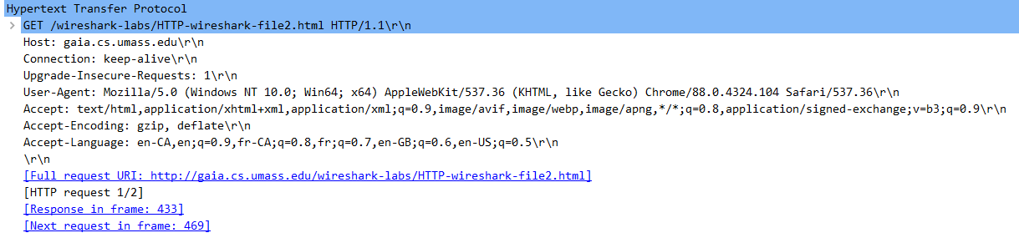
Figure 8: Question 8 If modified since

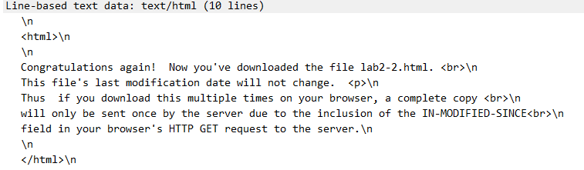
Figure 9: Question 9 File contents

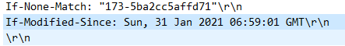
Figure 10: Question 10 second HTTP get request

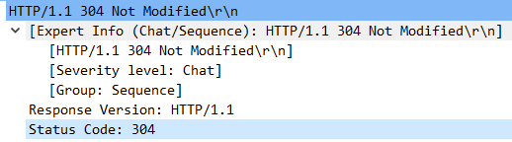
Figure 11: Question 11 server status code response

